The Millikan Oil Drop Experiment: A Measurement of e  
Aditya Pidaparti

School of Physics and Astronomy, University of Minnesota–Twin Cities, Minneapolis, MN, 55455

**Abstract**

Robert Millikan’s original oil drop experiment confirmed that charge was quantized to a fundamental constant e, with an accepted value of -1.602 *10-19 C1. This experiment’s results verify those findings, with a predicted e of , to within two uncertainties. This was verified by replicating Millikan’s experiment, except using polystyrene drops and measuring their motion in the presence of varying electric fields. The velocities of particles were noted, and their chargers were determined. Then, χ2 analysis was performed to determine a prediction of e that minimized the reduced *χ2*-value within an acceptable range of potential values of e. The prediction made by the χ2 analysis is stated above and matches literature.

**Introduction**

The Millikan oil drop experiment was performed in 1909 by Robert Millikan and Harvey Fletcher.2 The two sprayed charged drops of oil into a chamber with an electric field due to charged electrodes at either end and measuring the rate at which the drops fell or rose, depending on the electric field generated by the electrodes.

Millikan’s findings showed that all drops exhibited a discrete charge, all multiples of a constant *e*, which he measured to be 1.592 x10-19C, close to the current accepted value of 1.602x10-19C.1 At the time however, it was contentious whether electric charge was discrete or continuous, and his experiment conclusively proved the latter.

To test charge quantization, Millikan had charged droplets sprayed into a chamber and measured their terminal velocity. Then, he applied electric field as shown below in Figure 1. As the droplets are charged, they experience a force different from their free-fall motion in the presence of an electric field. This change in motion is recorded and the new terminal velocities are calculated. As developed below, the observation and calculation of the terminal velocities allows determination of the charge on any given droplet.



*Figure 1: Millikan’s oil drop apparatus.3 Charged droplets are sprayed form an atomizer into a chamber to observe their motion. Then, an applied electric field changes their motion, which will allow for the calculation of their charge.*

In free fall, a droplet is subject to three forces, the drag, buoyant, and gravitational forces, which are given by:

where η is the viscosity of air, *r* is the radius of the droplet, *v* is the droplet’s velocity, *g* is the gravitational constant, *m* is the mass of the droplet, is the density of air, and is the density of the droplet. At terminal velocity, the previous forces become equal, leading to a net force

By substituting Equations 1,2, and 3, the following is established:

Equation 4 can be rewritten as

to solve for the radius *r*, which is used to find the droplet’s mass *m*.

**

*Figure 2: Free body motion of the droplets with and without an electric field applied. The forces are Fdrag, Fbuoy, Fg, and FE, which respectively are the drag, buoyant, gravitational, and electric forces. The direction of the droplet is specified, and the notation for its terminal velocity is given by vg, vu, and vd for each of the three cases as shown. It should be noted that there is a fourth case, where the electric force points up, but the droplet still falls. This occurs when the electric force, alongside the drag and buoyant forces, cannot overcome gravity. However, the experiment had no cases of this result, so the mathematics are not described here.*

When an electric field *E* is applied to a droplet with charge *q*, the electric force changes its motion. In the middle droplet of Figure 2, the electric force causes the droplet to rise instead of fall, and at terminal velocity *vu*, its forces are described by

or, through substitution of Equations 1-3,

By solving for the droplet’s charge *q*, the following is obtained:

Using a similar argument for the right droplet of Figure 2, the charge of a droplet moving down in an electric field is given by

**Procedure**

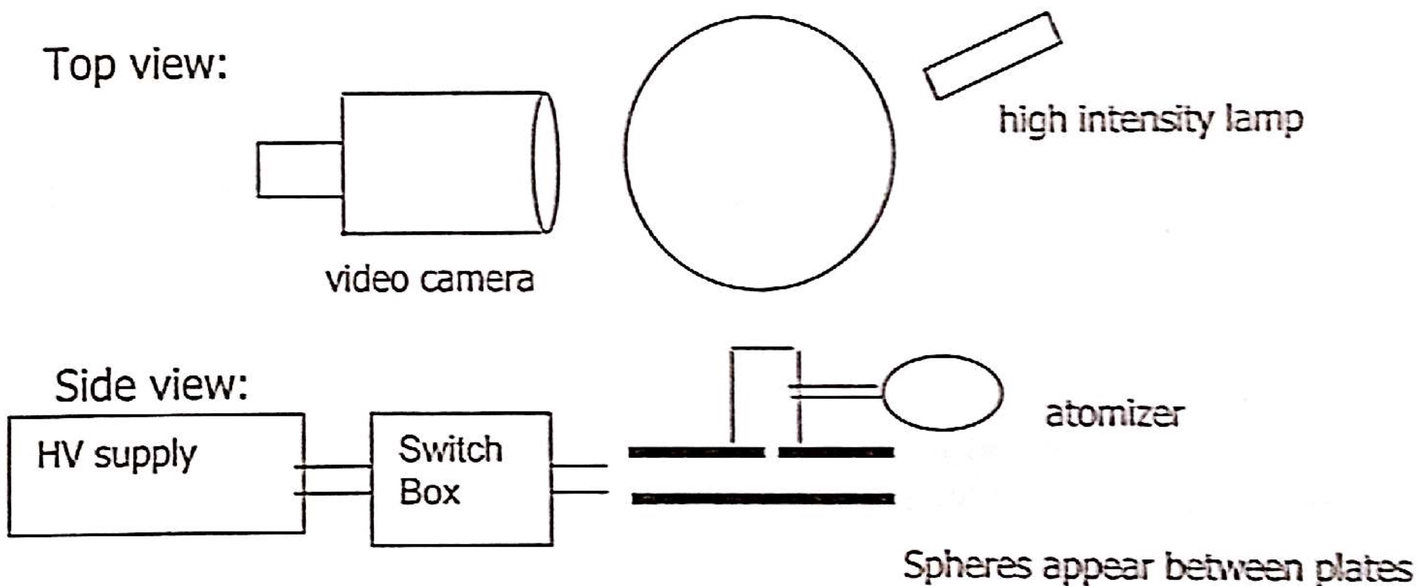

*Figure 3: The experiment setup.4*

To show the quantization of charge, droplets were observed as shown in the setup in Figure 3. The atomizer was pumped to fill the chamber with charged polystyrene droplets, which were viewed on a screen via the video feed. As the droplets settled, slow moving droplets were identified. To verify charge quantization, droplets with minimal (less than 10*e) charge imbalance had to be selected, so expected terminal velocities under an electric field for droplets with small charge were calculated. From these calculations, an electric field of 1kV was applied and droplets moving sufficiently slowly were analyzed.

For each drop, its time in free fall was measured twice. Then, an electric field causing the droplet to fall at a faster speed than free fall was applied and the time it took to fall was measure twice. Then, the electric field was reversed and the same process was done. This identification was done for 10 such drops.

For all calculations, the time for a drop to achieve terminal velocity was ignored and assumed negligible. By integrating Equation 4, the velocity *v(t)* is

where *t* is the time the drop has been in free fall in seconds and τ is the time for the drop to reach 63% of terminal velocity, given by

For a drop with a 1 μm radius, , so the time to reach terminal velocity can be assumed to be negligible. As such, particle data was taken given that terminal velocity was reached too quickly to be accounted for.

**Analysis**

The equations developed so far provide a good approximation with which to determine the quantized value of e. However, some corrections must be made to obtain more accurate results. First, the viscosity of air at temperature T (in Celsius) is given by

However, this viscosity is still an approximation, as the drag force in Equation 1 applies to streamline motion in a uniform fluid. The small size of the droplets requires a correction:

where a = 8.1 * 10-8m, *r* is the droplet’s radius, and *P* is a unitless measurement of the atmospheric pressure in atm. Substituting Equation 14 into Equation 6, squaring, and rearranging gives a quadratic equation

which has a first order solution of

For each droplet, the corrected radius and viscosity were found. Then, the charge was determined and further analyzed.

To determine a prediction of e, χ2 analysis was performed. For each drop, its charge was calculated. The following function was used to measure a χ2 value:

where yi is the calculated charge of data point i divided the predicted value of e and σyi is the uncertainty in the calculated charge of data point I divided by the predicted value of e. The χ2-value was then computed for predicted values of e in the range and are shown in Figure 4.

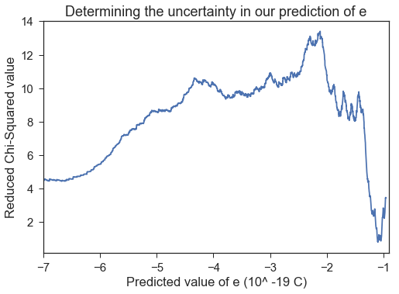

*Figure 4: The reduced χ2-value plotted against predicted values of e. Note the reduced χ2-value, which is the χ2-value divided by the degrees of freedom, is plotted against predictions of e. As there are 10 data points collected, there are 9 degrees of freedom. In addition, note the periodic troughs found close to the accepted value of e and the rapid decline of the reduced χ2-value once a prediction of e becomes small.*

Figure 4 shows the computed reduced χ2-values for a wide range of possible e, however as charge is quantized, that means that the data will show low χ2-values around and less than one-half the accepted value of e. If charge is quantized in integer multiples for some e, then one half of e will exhibit the same or better χ2-value, as all integer multiples of e are also integer multiples of one-half of e. In addition, as predictions of e grow smaller, random uncertainties in data will better support smaller values, as by chance smaller values are more likely to appear the base quantization of e since there are more integer multiples possible in a given range.

To account for the previous effect, only reduced χ2-values in the range of were considered, and are shown in Figure 5.

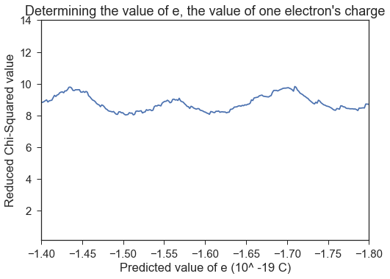

*Figure 5: A zoomed-in version of Figure 4, showing the reduced χ2-value only in the range (-1.40 to -1.80) * 10-19 Coulombs. In this range, a minimal reduced χ2-value was found, giving a prediction of e.*

In the range shown, the minimal reduced χ2-value was found to be 8.04. The uncertainty was found through finding the corresponding upper and lower bound of this minimal reduced χ2-value plus one. That is, the closest data points to areduced χ2-value of 9.04 were found on either side. The predicted value of e was found to be . This prediction is within two uncertainties of the accepted value of e of -1.602 * 10-19 C.1 In addition, on Figure 5, it is obvious there is a second trough to the right of the first one. The reduced χ2-value at this local minimum was 8.07, and calculations for a prediction of e were made. e was predicted as , within one uncertainty of the accepted value. As this result has a larger reduced χ2-value, it is discussed as a secondary result, not a primary one.

Sources of error in this lab included camera resolution and timing. The former was addressed by approximating the size of each droplets to be ½ of ½ of one ruler tic marks (for calibration, there were 11 ruler tic marks covering the 4 camera tic marks, and each was , so the uncertainty was taken as of an inch. The timing of the droplets was a large error source, so two trials were taken for each droplet. The results were averaged together for one measurement, and their difference was used as the uncertainty. The measured uncertainty from this method outweighed any impacts from reaction time, so reaction time was ignored as an uncertainty. To improve this experiment, suggested steps would be to automate the taking of data so that hundreds of data points could be taken instead of 10. This would give better predictions as identification and measuring of droplets was difficult and qualitative in nature. With machine precision, dots even with charges with more than 10*e could be accounted for and used to extrapolate a value of e.

**Conclusion**

The quantized fundamental value e was verified to within two uncertainties via reduced χ2-analysis. This meant computing the reduced χ2-values across a wide range of potential values for e, and taking the minimum χ2-value within a range the accepted value of e was known to be in. e was found to be –(1.50 +- 0.06) * 10-19 C in a local minimum, compared to an accepted value of -1.602 * 10-19 C.1 This constitutes a 6.25% error and can verifies literature. In the second local minimum, e was found as , within one uncertainty of the accepted value and with a 0.50% error.

Error sources in this lab were camera resolution and timing, which were accounted for by taking an upper bound of potential error for the former and multiple trials for the latter. Improvements on this experiment would involve automation of the data-taking process, as it was laborious, slow, and human-error prone. Steps were taken to mitigate the error, but machine precision would enable more accurate results.

**References**

1. Millikan, Robert Andrews. "The Isolation of an Ion, a Precision Measurement of its Charge, and the Correction of Stokes's Law." Physical Review (Series I) 32.4 (1911): 349.
2. "Robert Millikan". APS Physics. Retrieved 26 April 2016.
3. "Millikan Oil-drop Experiment." Encyclopædia Britannica. Encyclopædia Britannica, Inc., n.d. Web. 10 Apr. 2017
4. Huang, Cheng-Cher, and Julie Vievering. PHYS 2605 Modern Physics Lab Manual. Minneapolis, MN: U of Minnesota, 2017. Print.

**Appendix: Data**

|  |  |  |
| --- | --- | --- |
| Constants | Values | Units |
| Density of drops (ρ) | 1050 | kg/m^3 |
| Density air (ρair) | 1.225 | kg/m^3 |
| Viscosity (η) | 1.85E-05 | kg/(m*s) |
| η Uncertainty | 2.34E-08 | kg/(m*s) |
| Temperature (T) | 22.33 | C |
| T Uncertainty | 0.26 | C |
| Calibration markings | 0.015625 | in |
| 1 Tick mark distance | 0.0011 | m |
| Plate separation | 0.01905 | m |
| Potential (V) | -1.003 | kV |
| δV | 0.001 | kV |
| Electric Field (V/m) | -5.27E+04 | V/m |
| δE | 5E+01 | V/m |
| δd (m) | 2E-04 | m |

*Table 1: Constants for the experiment.*

|  |  |  |  |  |  |  |  |  |
| --- | --- | --- | --- | --- | --- | --- | --- | --- |
| Drop | Ticks Fell | Distance fell (m) | Fall Time (s) | Up Time (s) | Down Time (s) | δ Fall (s) | δ Up (s) | δ Down (s) |
| 1 | 4 | 4.4E-03 | 83.34 | 9.70 | 7.87 | 2.33 | 0.11 | 0.06 |
| 2 | 4 | 4.4E-03 | 61.79 | 11.17 | 8.18 | 0.10 | 0.08 | 0.32 |
| 3 | 4 | 4.4E-03 | 64.72 | 11.32 | 8.18 | 5.32 | 0.07 | 0.30 |
| 4 | 4 | 4.4E-03 | 116.96 | 20.83 | 14.15 | 9.88 | 1.23 | 1.98 |
| 5 | 1 | 1.1E-03 | 19.57 | 29.48 | 6.80 | 4.39 | 1.47 | 0.47 |
| 6 | 1 | 1.1E-03 | 27.19 | 39.03 | 9.47 | 0.48 | 1.50 | 0.05 |
| 7 | 1 | 1.1E-03 | 43.00 | 49.90 | 15.16 | 1.08 | 0.67 | 0.29 |
| 8 | 1 | 1.1E-03 | 42.21 | 18.23 | 9.15 | 0.49 | 0.81 | 0.16 |
| 9 | 1 | 1.1E-03 | 38.20 | 59.54 | 14.43 | 1.91 | 1.28 | 0.37 |
| 10 | 1 | 1.1E-03 | 27.37 | 39.31 | 9.52 | 1.33 | 0.45 | 0.51 |

|  |  |  |  |  |  |  |  |  |
| --- | --- | --- | --- | --- | --- | --- | --- | --- |
| Drop | V_g (m/s) | δ V_g (m/s) | V_up (m/s) | δ V_up (m/s) | V_down (m/s) | δ V_down (m/s) | Radius (m) | δr (m) |
| 1 | 5.24E-05 | 2.8E-06 | 4.50E-04 | 2.11E-05 | 5.55E-04 | 2.6E-05 | 6.50E-07 | 1.7E-08 |
| 2 | 7.07E-05 | 3.2E-06 | 3.91E-04 | 1.80E-05 | 5.34E-04 | 3.2E-05 | 7.55E-07 | 1.7E-08 |
| 3 | 6.75E-05 | 6.3E-06 | 3.86E-04 | 1.77E-05 | 5.34E-04 | 3.1E-05 | 7.38E-07 | 3.5E-08 |
| 4 | 3.73E-05 | 3.6E-06 | 2.10E-04 | 1.56E-05 | 3.09E-04 | 4.5E-05 | 5.49E-07 | 2.6E-08 |
| 5 | 5.58E-05 | 1.6E-05 | 3.70E-05 | 7.0E-06 | 1.61E-04 | 3.1E-05 | 6.71E-07 | 9.7E-08 |
| 6 | 4.01E-05 | 7.3E-06 | 2.80E-05 | 5.2E-06 | 1.15E-04 | 2.1E-05 | 5.69E-07 | 5.2E-08 |
| 7 | 2.54E-05 | 4.7E-06 | 2.19E-05 | 4.0E-06 | 7.2E-05 | 1.3E-05 | 4.53E-07 | 4.2E-08 |
| 8 | 2.59E-05 | 4.7E-06 | 5.99E-05 | 1.12E-05 | 1.19E-04 | 2.2E-05 | 4.57E-07 | 4.2E-08 |
| 9 | 2.86E-05 | 5.4E-06 | 1.83E-05 | 3.4E-06 | 7.57E-05 | 1.4E-05 | 4.80E-07 | 4.5E-08 |
| 10 | 3.99E-05 | 7.5E-06 | 2.78E-05 | 5.1E-06 | 1.15E-04 | 2.2E-05 | 5.67E-07 | 5.3E-08 |

|  |  |  |  |  |  |  |  |  |  |  |
| --- | --- | --- | --- | --- | --- | --- | --- | --- | --- | --- |
| Drop | r_corr (m) | δr_corr (m) | η_corr (kg/m*s) | δη_corr (kg/m*s) | Charge Down (C ) | δ q_down (C ) | Charge Up(C ) | δ q_up | q/e Down | q/e Up |
| 1 | 6.10E-07 | 1.7E-08 | 1.63E-05 | 6E-08 | -1.79E-18 | 5E-20 | -1.79E-18 | 6E-20 | 11.1 | 11.2 |
| 2 | 7.15E-07 | 1.7E-08 | 1.66E-05 | 5E-08 | -1.96E-18 | 5E-20 | -1.96E-18 | 6E-20 | 12.3 | 12.2 |
| 3 | 6.97E-07 | 3.5E-08 | 1.65E-05 | 9E-08 | -1.92E-18 | 9E-20 | -1.87E-18 | 1E-19 | 12.0 | 11.7 |
| 4 | 5.08E-07 | 2.6E-08 | 1.59E-05 | 1E-07 | -7.86E-19 | 4E-20 | -7.15E-19 | 5E-20 | 4.9 | 4.5 |
| 5 | 6.30E-07 | 9.7E-08 | 1.64E-05 | 3E-07 | -3.87E-19 | 5E-20 | -3.43E-19 | 1E-19 | 2.4 | 2.1 |
| 6 | 5.29E-07 | 5.2E-08 | 1.60E-05 | 2E-07 | -2.28E-19 | 2E-20 | -2.06E-19 | 5E-20 | 1.4 | 1.3 |
| 7 | 4.12E-07 | 4.2E-08 | 1.54E-05 | 3E-07 | -1.06E-19 | 1E-20 | -1.08E-19 | 2E-20 | 0.7 | 0.7 |
| 8 | 4.16E-07 | 4.2E-08 | 1.54E-05 | 3E-07 | -2.15E-19 | 2E-20 | -1.97E-19 | 3E-20 | 1.3 | 1.2 |
| 9 | 4.40E-07 | 4.5E-08 | 1.56E-05 | 3E-07 | -1.16E-19 | 1E-20 | -1.15E-19 | 3E-20 | 0.7 | 0.7 |
| 10 | 5.27E-07 | 5.3E-08 | 1.60E-05 | 2E-07 | -2.26E-19 | 2E-20 | -2.04E-19 | 5E-20 | 1.4 | 1.3 |

*Tables 2-4: Experimental data and intermediate calculations*

**Appendix: Further Information**

For further information and to directly access and run the code used to create these results, please email [pidap004@umn.edu](mailto:pidap004@umn.edu) or go to [github.com/indianswimmer](http://github.com/indianswimmer). The analysis was stored in an IPython interactive notebook.